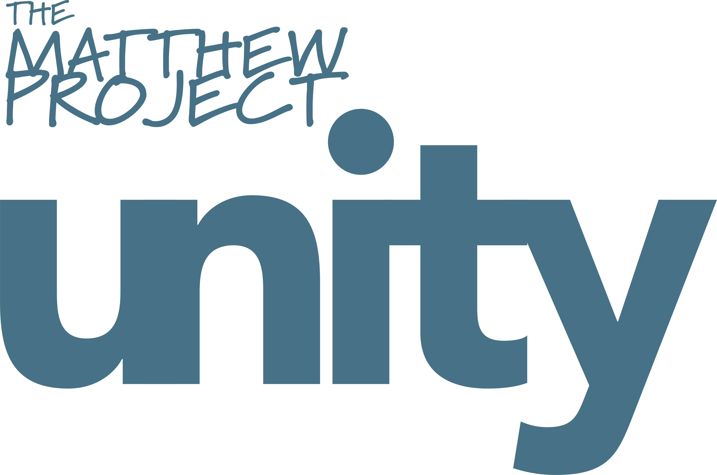

Referral date

Young Person’s Details
Does the young person consent to the referral? |  |  | ☐Yes ☐ No - if no, please inform referrer that this consent needs to be sought before we are able to accept the referral.
First name |  |  |  |  | Surname
Date of Birth |  |  |  |  | Age
If young person is under 13, parental consent is required. Does the parent consent to the referral? |  |  |  |  | ☐Yes ☐ No - if no, please inform referrer that this consent needs to be sought before we are able to accept the referral.

If young person is over 19, please give details around learning disability or vulnerability
Sex |  | ☐ Male ☐ Female |  |  | Nationality
Disabilities |  |  |  |  | Speaks English | ☐ Yes ☐ No
Religious beliefs |  |  |  |  | Ethnicity

Address
 |  |  |  | Postcode
Contact Number |  |  |  | Contact Info
Alt Contact Number |  |  |  | Alt Contact Info

Guardian Details
Are parents / carers aware of this referral? |  | ☐ Yes ☐ No  If the child/young person is under 13, consent from parent/carers will be required

If not, why?
Name of next of kin |  | Relationship
Contact number |  | Alternative Contact number

Contact Info e.g. best time to call

Referrer Details

Name of referrer

Relationship to client

Name and address of organisation

Contact number

Contact info eg best time to call

E-mail address

Initial contact arrangements e.g. will referrer set up first appointment, contact young person directly

How did you hear about our service?

Referral Information

Reason for referral / additional information

- What happened to prompt referral?
- How is yp affected?
- Ask about friends, family, positive and negative things.
- What are they worried about?
- What is yp worried about?
- Does the user acknowledge the impact on yp?
- What has happened so far for support?
- Mental health?
- Police? YOT?
- School/college support?
- What does yp hope to get from our service? YP views.
- If appropriate, any cse/cce risk screening
- Any witnessing/experiencing domestic abuse/ ACE’s we should be aware of?

Impact on Young Person  How is the situation affecting yp? (behaviour, emotional, stability in housing and finances, school etc) |  | Young Person’s viewpoint  What have they said – Yp’s words. Do they want support? What needs to change?
Young Carer | ☐ Yes ☐ No
Any potential risks or concerns | Also any risks to worker doing home visit, is it recommended or are there other people there who aren’t safe?  Any pets? (allergies, dog bites etc.)
Who is the user?  Gender of user | ☐ Parent ☐ Step Parent ☐ Sibling ☐ Other:  ☐ Female ☐ Male
Is user living with family? | ☐ Yes  ☐ No |  | Is the user aware of the referral | ☐ Yes ☐ No
Substance Type 1 | ☐ Current ☐ Historical
Substance Type 2 | ☐ Current ☐ Historical
Substance Type 3 | ☐ Current ☐ Historical

Other information about substance use
Is the user currently receiving support for their substance use? | ☐ Yes, please give details:  ☐ No

Multi Agency
Is the family receiving any statutory interventions? | ☐ Section 17 – Child in Need ☐ Section 47 – Child Protection  ☐ FSP ☐ Other Children Services Involvement ☐ No ☐ Not known

Lead Professional/Social Worker
Are there any other services involved with the family? E.g young carers |  | Young Carers, YOT, education, Early help etc

Which education provision is the child/young person attending?

