Date referral

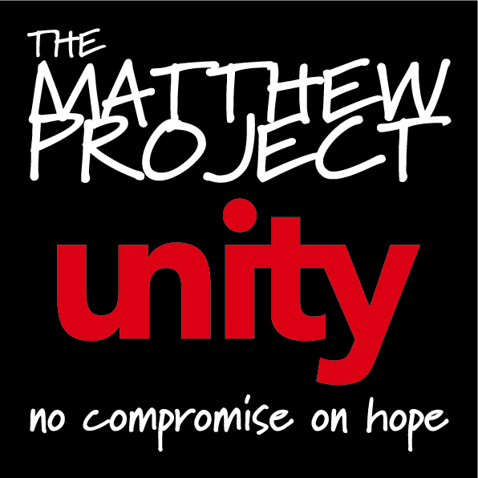
Client Details
Does the young person consent to the referral? |  |  | ☐Yes ☐ No - if no, please inform referrer that this consent needs to be sought before we are able to accept the referral.
Forename |  |  | Family Name
Nickname |  |  | Previous Family Name
Date of Birth |  |  | Age
If young person is under 13, parental consent is required. Does the parent consent for the young person to be referred to us? |  |  | ☐Yes ☐ No - if no, please inform referrer that this consent needs to be sought before we are able to accept the referral.

If young person is over 19, please give details around learning disability or vulnerability
Gender | ☐Male ☐ Female |  | Nationality
Preferred Language |  |  | Speaks English |  | ☐Yes ☐ No
Religious beliefs |  |  | Ethnicity

Disabilities

Address

Postcode
Contact Number |  |  |  | Contact Info (i.e mums mobile, contact times)
Alternative Contact Number |  |  |  | Alternative Contact Info

Guardian Details
Are parents / carers aware of this referral? |  |  | ☐ Yes ☐ No

If not, why?
Name of next of kin |  | Relationship

Contact number(s)

Contact Info eg best time to call

Referrer Details

Name of referrer

Name and address of organisation

Relationship to client
Mobile number |  | Phone number

Contact info e.g. best time to call

E-mail address

How did you hear about our service?
Is the client a parent/carer of young person using substances? | ☐Yes ☐ No

Reason for referral / General notes

What happened to prompt referral?

What are they using?

How much/how often?

How long have they been using?

Ask about friends, family, positive and negative things.

What are they worried about?

What does yp think about their behaviour/drug use?

What do parents think?

What has happened so far for support?

Mental health?

Police? YOT?

School/college support?

What does yp hope to get from our service? YP views. (check yp has actually said why they want support)

If appropriate, any cse/cce risk screening

Any witnessing/experiencing domestic abuse/ ACE’s we should be aware of?

Substance* | Frequency | Quantity | Route* |  |  | Cost | Last used | Age first used* | Prescribed

1

2

3
Has the young person ever injected? |  | ☐ Previously ☐ Currently ☐ Never ☐ Client declined to answer
Has the young person injected the last 30 days? |  |  |  | ☐ Yes ☐ No
Any potential risks or concerns  If referrer has a risk assessment for client,  request a copy |  | Also any risks to worker doing home visit, is it recommended or are there other people there who aren’t safe?  Any pets? (allergies, dog bites etc.)

Initial contact arrangements e.g. will referrer set up first appointment, contact young person directly

Multi Agency
Is the family receiving any statutory interventions? | ☐ Section 17 – Child in Need Section 47 – Child Protection ☐ LAC  ☐ FSP ☐ Other Children Services involvement ☐ No ☐ Not known

Lead Professional/Social Worker
Are there any other services involved with the family? | Young Carers, YOT, education, Early help etc.

Client GP details

GP Surgery

Phone number

Address

Please return referral form via email to: unity@matthewproject.org

